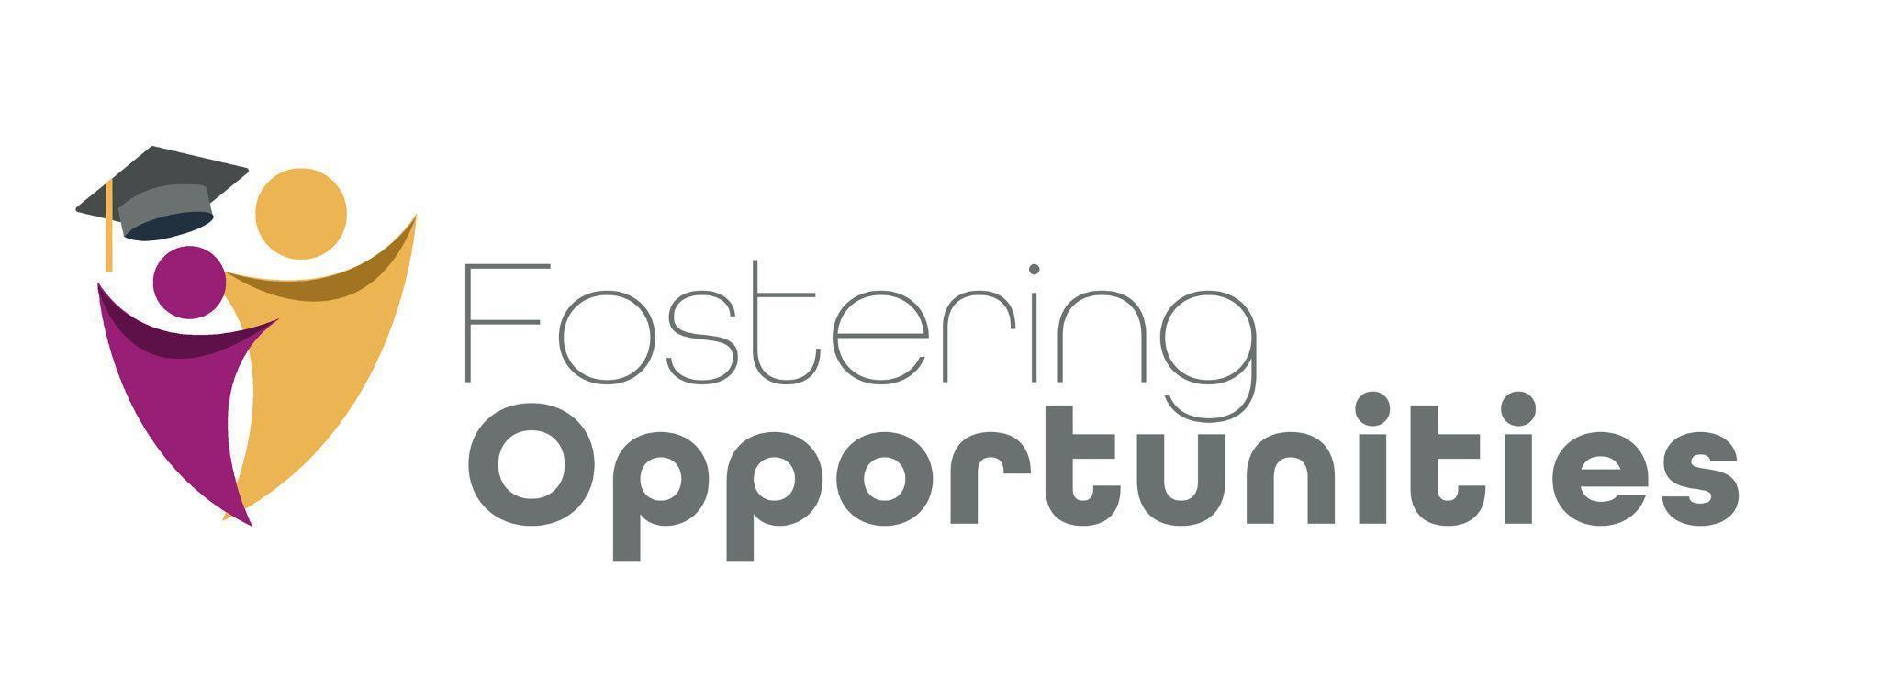Fostering Opportunities Implementation (FOI)

Pre-Launch Checklist

This checklist can be used by Fostering Opportunities leadership and staff involved in child welfare and education leadership to guide the building period before the first year of implementation.

* This checklist should be completed by the State Intermediary.
* This tool is recommended to be used during the pre-launch period (i.e., building period), a year prior to implementation.
* The tool is recommended to be used quarterly with the rating occurring in the following month. For example, if evaluating Quarter 1 (July 1 – September 30), ratings will be completed in the month of October.
* Comments can be used to note information that can streamline future quarter ratings, such as when data sharing agreements expire.

| **Roles** |  |
| --- | --- |
| State Intermediary: | Colorado Department of Human Services employee or contractor who facilitates selection of sites, cross-site learning, and reporting to the legislature. |
| Program Coordinator: | School district employees identified as the lead for implementation of the Fostering Opportunities program in a given school district. |
| Specialist: | School district employees who provide direct services to students. |

| **Timeline** |  |
| --- | --- |
| Pre-Launch Period | Year prior to implementation, also known as the building period. |
| Initial Implementation Period | The first year of implementation of the program or until the program reaches fidelity. |
| Established Period | Typically year two plus of implementation of the program. |

| Date: |  |
| --- | --- |
| Program Location/Site: |  |
| State Intermediary: |  |
| Specialist Name: |  |

| **SYSTEMS ALIGNMENT: Systems alignment refers to the education and child welfare policy and practice coordination that is the foundation for successful implementation of the Fostering Opportunities intervention.** |
| --- |
| 1. **Education and child welfare leaders participate in regularly scheduled meetings to launch the program.** |
| * **Yes** * **No** |
| **Comments:** |
| 1. **Fostering Opportunities leaders developed orientation and informational materials for caseworkers and school building leaders (e.g., principals) to become familiar with the Fostering Opportunities program.** |
| * **Yes** * **No** |
| **Comments:** |
| 1. **A plan is developed to generate a referral network or other formalized process to identify eligible students.** |
| * **Yes** * **No** |
| **Comments:** |
| 1. **Outreach materials are developed to recruit and enroll students AND to share with foster/kin caregivers, parents, Child Welfare, Court Appointed Special Advocates (CASA), and guardians ad litem (GALs).** |
| * **Yes** * **No** |
| **Comments:** |
| 1. **The site has developed Memorandums of Understanding or other formalized documents that clarify the responsibilities of the child welfare and education agencies.** |
| * **Yes** * **No** |
| **Comments:** |
| 1. **The site has developed data sharing agreements that detail what information can be shared between agencies for the purposes of delivering and evaluating the program.** |
| * **Yes** * **No** |
| **Comments:** |
| 1. **The site has developed releases of information (ROI), which are student-specific documents that indicate what information can be shared, with whom, and for how long. Best practice is for the ROI forms to be inclusive of professional roles that are often relevant to this population's network of support (e.g., GAL, CASA).** |
| * **Yes** * **No** |
| **Comments:** |

